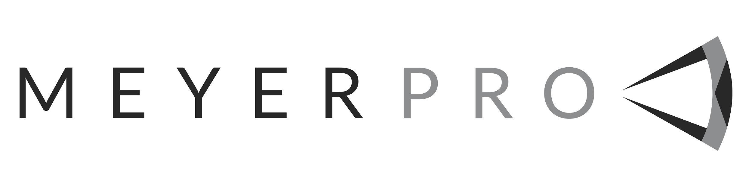Audio Visual Tech Position

MeyerPro is seeking an Audio Visual technician to join our growing company.
This position is a full-time, non exempt position. The position is a multi faceted role that can become a lead tech role based on experience and comfort. The responsibilities of the position will be determined on a day to day basis as to what best serves the client and our company.
You must be self motivated, able to problem solve, enthusiastic, organized, have a positive attitude, work well in a team environment, and have good communication skills.

Duties
- Work with shop staff to prep and help prep equipment for upcoming shows, including will-call rentals as time allows.
- Assisting in the load-in/out, setup, operation and tear-down of audio visual equipment based on the needs of the event. This includes but is not limited to audio systems, projectors, projection screens, displays, LED wall, cameras, lighting.
- Operating equipment on events. This is based on your area of expertise.
- Warehouse work including quality control and maintenance of equipment, scanning equipment in/out, show prep, putting away and organizing gear.
- Occasionally may be asked to deliver/pick up equipment to/from clients or venues that involves driving a box truck or sprinter van.
- Minor tasks such as answering the phone on occasion, writing up quotes and assisting will-call customers but this will only make up about 5% of the position.
- Ensure quality and functionality of equipment and inventory before and after use.

Requirements
- Follow established company best practices and procedures for sets, shows, strikes and warehouse tasks.
- Must be able to work as a team keeping MeyerPro and our clients best interest in mind at all times.
- Positive and collaborative attitude when solving problems.
- Excellent customer service skills
- Ability to follow instructions.
- Good communication skills
- Ability to lift 75lbs
- Neatness of appearance

To apply for this position please send resume and cover letter to jobs@meyerproinc.com.

